EX.NO:01 | EVENT MANAGEMENT PLATFORM
DATE:

1.AIM:To create a web-based event management system using web technologies that supports a platform where users can browse, register for, and manage events, while organizers can create and track event participation.
2.PROCEDURE:
Step 1
Create a folder named
Event-Management-System
Step 2
Create the following files inside it:
- index.html
- register.html
- organizer.html
- style.css
- script.js
Step 3
Copy the respective code into each file.
Step 4
Open index.html using:
- Google Chrome / Edge / Firefox
Step 5
Navigate using menu:
- Home → View events
- Register → Register for an event
- Organizer → Create new events

Specify Folder Name : Event-Management-System in VS Code:
├── index.html (Home & Event Listing)
<!DOCTYPE html>
<html lang="en">
<head>
<meta charset="UTF-8">
<title>Event Management Platform</title>
<link rel="stylesheet" href="style.css">
</head>
<body>

<header>
<h1>Online Event Management Platform</h1>
<p>Browse and Register for Events</p>
</header>

<nav>
<a href="index.html">Home</a>
<a href="register.html">Register</a>
<a href="organizer.html">Organizer</a>
</nav>

<section>
<h2>Available Events</h2>
<table>
<tr>
<th>Event Name</th>
<th>Date</th>
<th>Location</th>
</tr>
<tr>
<td>Tech Workshop</td>
<td>15 Feb 2026</td>
<td>Computer Lab</td>
</tr>
<tr>
<td>Cultural Fest</td>
<td>20 Feb 2026</td>
<td>Auditorium</td>
</tr>
<tr>
<td>Sports Meet</td>
<td>25 Feb 2026</td>
<td>Playground</td>
</tr>
</table>
</section>

<footer>
<p>&copy; 2026 Event Management System</p>
</footer>

</body>
</html>

├── register.html (User Registration Page)
<!DOCTYPE html>
<html>
<head>
<title>Event Registration</title>
<link rel="stylesheet" href="style.css">
<script src="script.js"></script>
</head>
<body>

<header>
<h1>User Event Registration</h1>
</header>

<nav>
<a href="organizer.html">Next ➡ Go Next to Organizer Dashboard</a>
</nav>
<nav>
<a href="index.html">Back ➡ Go Back to Index Page</a>
</nav>

<form onsubmit="return registerEvent()">
<label>Name:</label>
<input type="text" id="name" required>

<label>Email:</label>
<input type="email" id="email" required>

<label>Select Event:</label>
<select id="event">
<option>Tech Workshop</option>
<option>Cultural Fest</option>
<option>Sports Meet</option>
</select>

<button type="submit">Register</button>
</form>

<p id="msg"></p>

</body>
</html>

├── organizer.html (Organizer Event Creation)
<!DOCTYPE html>
<html>
<head>
<title>Organizer Panel</title>
<link rel="stylesheet" href="style.css">
</head>
<body>

<header>
<h1>Organizer Dashboard</h1>
</header>

<nav>
<a href="register.html">Back ➡ Go Back to Register Dashboard</a>
</nav>

<form id="eventForm">
<label>Event Name:</label>
<input type="text" id="eventName" required>

<label>Date:</label>
<input type="date" id="eventDate" required>

<label>Location:</label>
<input type="text" id="location" required>

<button type="submit">Create Event</button>
</form>

<p id="eventMsg" style="text-align:center; font-weight:bold; color:green;"></p>

<!-- Script loaded AFTER HTML -->
<script src="script.js"></script>
</body>
</html>

├── style.css (Styling)
body {
font-family: Arial;
background-color: #f4f6f8;
margin: 0;
padding: 0;
}

header {
background-color: #2b6777;
color: white;
padding: 20px;
text-align: center;
}

nav {
background-color: #52ab98;
padding: 10px;
text-align: center;
}

nav a {
color: white;
margin: 10px;
text-decoration: none;
font-weight: bold;
}

section {
padding: 20px;
}

table {
width: 100%;
border-collapse: collapse;
}

table, th, td {
border: 1px solid #444;
}

th, td {
padding: 10px;
text-align: center;
}

form {
background: white;
width: 40%;
margin: 30px auto;
padding: 20px;
border-radius: 8px;
}

label {
display: block;
margin-top: 10px;
}

input, select, button {
width: 100%;
padding: 8px;
margin-top: 5px;
}

button {
background-color: #2b6777;
color: white;
border: none;
margin-top: 15px;
cursor: pointer;
}

button:hover {
background-color: #1b4f5f;
}

footer {
background-color: #333;
color: white;
text-align: center;
padding: 10px;
}

└── script.js (Logic & Validation)
function registerEvent() {
let name = document.getElementById("name").value;
let event = document.getElementById("event").value;

document.getElementById("msg").innerHTML =
"=>" + name + " successfully registered for " + event;

return false; // prevent page reload
}

document.addEventListener("DOMContentLoaded", function () {

document.getElementById("eventForm").addEventListener("submit", function (e) {
e.preventDefault(); // Stops page reload

let eventName = document.getElementById("eventName").value;
let eventDate = document.getElementById("eventDate").value;
let location = document.getElementById("location").value;

document.getElementById("eventMsg").innerHTML =
"The Event Name:<b>" + eventName + "</b> on <b>" +
eventDate + "</b> at <b>" + location +
"</b> created successfully.";

this.reset(); // optional: clears form
});

});

3.SAMPLE INPUT OUTPUT:
Index Page:
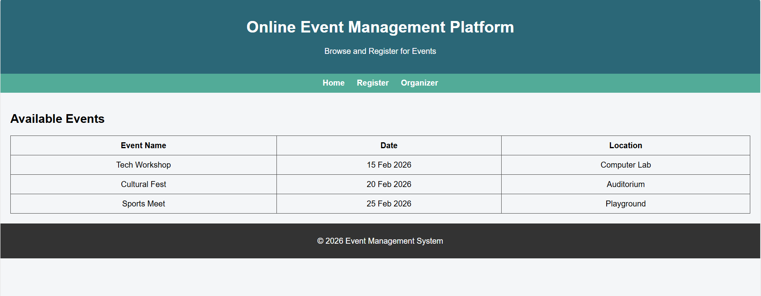
Register Page:
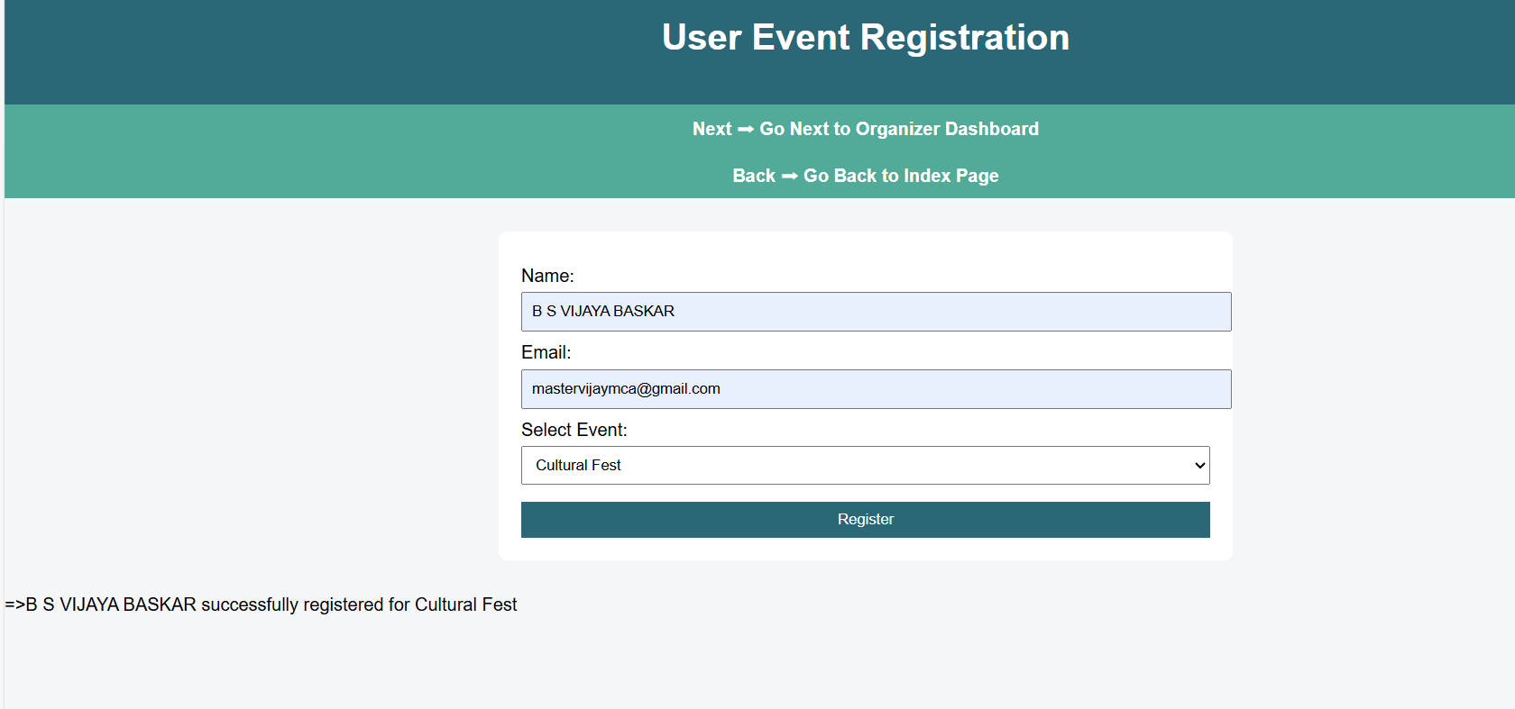

Organizer Page:
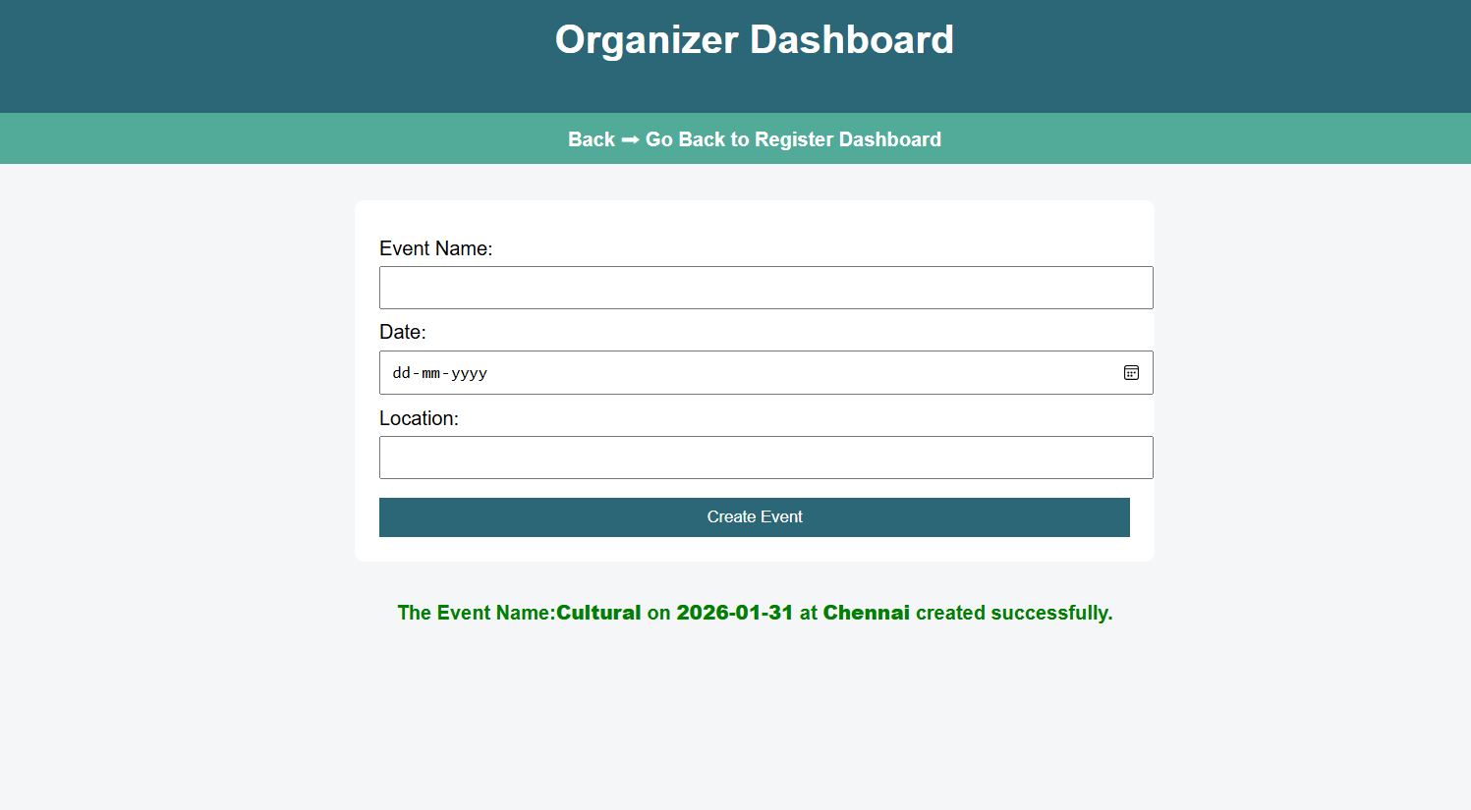
5.RESULT :
Thus, the Event Management Platform using HTML, CSS, and JavaScript was designed and executed successfully. The system allows users to view and register for events, while organizers can create events and track participation.

